**#0 Calculator**

Write a code only using “if” construction that works the same **switch … case** statement.

1. Ask the user to enter two numbers.
2. Ask the user to choose an operation (addition, subtraction, multiplication, or division).
3. Perform the selected operation on the two numbers.
4. Display the result.

Your code should handle all possible exceptions.

**Sample Input 1:**

Please enter the first number: 5

Please enter the second number: 9

Please choose the operation : /

**Sample Output 1:**

5 / 9 = 0.556

**#1 Ratio**

Write a program that checks that the following relation holds for a given four-digit number: the sum of the first and last digits is equal to the difference between the second and third digits.

**Input format**   
The program is given a single positive four-digit integer as input.

**Output format**   
The program should output " YES " if the ratio is true, and "NO" — if not executed.

Test data 🟢

**Sample Input 1:**

1614

**Sample Output 1:**

yes

**Sample Input 2:**

1234

**Sample Output 2:**

no

**#2 Roskomnadzor**

Write a program that determines whether a user is allowed to access an Internet resource or not.

**Input data format**   
The program is given an integer — the user's age.

**Output format**   
The program should output the text "Access allowed" if the age is at least 18, and "Access denied" otherwise.

Test data 🟢

**Sample Input 1:**

16

**Sample Output 1:**

Access denied

**Sample Input 2:**

18

**Sample Output 2:**

Access is allowed

**#3 Arithmetic progression**

Write a program that determines whether three given numbers (in the specified order) are consecutive terms[of an arithmetic progression](https://ru.wikipedia.org/wiki/%D0%90%D1%80%D0%B8%D1%84%D0%BC%D0%B5%D1%82%D0%B8%D1%87%D0%B5%D1%81%D0%BA%D0%B0%D1%8F_%D0%BF%D1%80%D0%BE%D0%B3%D1%80%D0%B5%D1%81%D1%81%D0%B8%D1%8F).

**Input format**   
The program receives three numbers as input, each on a separate line.

**Output format**

Test data 🟢

**Sample Input 1:**

1

2

3

**Sample Output 1:**

YES

**Sample Input 2:**

1

2

4

**Sample Output 2:**

NO

**#4 Rook Move**

Two different cells of the chessboard are given. Write a program that determines whether a rook can move from the first square to the second in one move. The program receives as input four numbers from 1 to 8 each, specifying the column number and row number first for the first cell, then for the second cell. The program should output " YES "if the rook's move from the first square can get to the second, or" NO " otherwise.

**Input format**   
The program is fed four numbers from 1 to 8.

**Output format**   
The program should output text in accordance with the task condition.

**Note**. The chess rook moves horizontally or vertically.

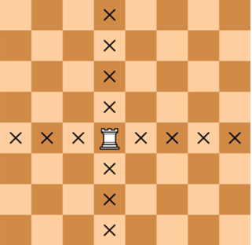

Test data 🟢

**Sample Input 1:**

4

4

5

4

**Sample Output 1:**

YES

**Sample Input 2:**

4

4

5

5

**Sample Output 2:**

NO

**#5 King's Move🌶 ️**

Two different cells of the chessboard are given. Write a program that determines whether the king can move from the first square to the second in one move. The program receives as input four numbers from 1 to 8 each, specifying the column number and row number first for the first cell, then for the second cell. The program should output " YES "if you can move from the first square of the king to the second, or" NO " otherwise.

**Input format**   
The program is fed four numbers from 1 to 8.

**Output format**   
The program should output text in accordance with the task condition.

**Note**. The chess king moves horizontally, vertically and diagonally, but only by 1 square.

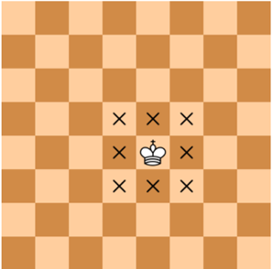

Test data 🟢

**Sample Input 1:**

4

4

5

5

**Sample Output 1:**

YES

**Sample Input 2:**

4

4

5

4

**Sample Output 2:**

YES

**#6 Average number**

Three different integers are given. Write a program that finds the average of the largest numbers.

**Input format**   
The program is fed three different integers, each on a separate line.

**Output format**   
The program should output the average number.

**Note.** The average number is the number that comes second if the three numbers are sorted in ascending order.

Test data 🟢

**Sample Input 1:**

1

2

3

**Sample Output 1:**

2

**Sample Input 2:**

10

30

20

**Sample Output 2:**

20